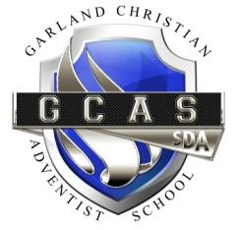

Uniform Requirements

Grades (Pre-K - 6)
Boys | Girls
Khaki shorts or pants | Khaki shorts or pants
Navy or light blue polo shirt with school logo | Navy or light blue polo shirt with school logo
Black belt | Black belt
Navy socks | Navy socks
Black or white shoes | Black or white shoes
PE – All Grades
Boys | Girls
Blue shorts | Blue shorts
School T-shirt | School T-shirt
Black or white tennis shoes | Black or white tennis shoes
Chapel (Wednesdays)
Boys | Girls
Blue pants | Navy Jumper
White short or long sleeve shirt | White Peter-Pan blouse
Blue tie | Navy Tie
Black belt | Navy socks
Navy socks | Black shoes
Black shoes
Blue Cardigan sweater (optional)
Additional Acceptable Clothing Accessories
School Hoodie with GCAS logo
Blue sweater with school logo or no logo

Uniform Order Form
To order GCAS polo, shirts, and hoodies, please fill out the information below. Submit this form along with your total payment to the school. Make checks payable to: GCAS
Youth
Sizes: 6/8(S), 10/12 (M), 14/16 (L), 18/20 (XL)
Cost: Polo $18.00; School T-shirt $11.00; Hoodie $30.00

Adult
Sizes: S, M, L, XL, 2X, 3X
Cost: $19.00; School T-shirt $12.00; Hoodie $35.00

Name:

Phone Number:

Email Address:

QTY | Item | Color | Size | Cost | Total
 |  |  |  | Shipping
 |  |  |  | Grand Total

